
Consumer Reports Package Instructions
HireRight Information
AND
Frequently Asked Questions


Table of Contents:
HireRight Application Process……………………………………………………………………………………………….. 1, 2
Frequently asked questions…………………………………………………………………………………………………... 2,3

hireright application instructions

WHO WILL RECEIVE A REQUEST TO COMPLETE THE HIRERIGHT PROCESS?

Each Approved Attorney Applicant and/or Escrow/Trust Signatory of the Firm; or each Escrow/Trust Signatory for an Independent Settlement Service Provider must submit a Consumer Report request through First American’s business partner, HireRIght.

The purpose of this document is to provide step-by-step instructions on how to complete the HireRight report submission as part of the application process with First American to ensure your personal information is secure.

Step 1:
Click the link in the email notification from HireRight Customer Support to access the website.
Step 2:
Use the login credentials provided in the notification email to gain access.

Step 3:
Click Start, which will prompt a password reset.
NOTE: If you wish to receive alerts and status updates from HireRight by text message or mobile phone, check the box and enter your phone number.

Step 4:
Click Next to begin.

Step 5:
Complete all appropriate fields and click Next. Fields with a red asterisk(*) are required.
NOTE: If requesting an appointment in Virginia, please provide identification number used to obtain your Virginia title license in the space below. This only applies to individuals doing business in Virginia

Step 6:
Verify all information provided is accurate and click Next.

Step 7:
Review the Consumer Disclosure and Authorization Form terms and provide electronic signature holding down your left mouse button and drawing your signature in the area provided.

Step 8:
Check the certification boxes to confirm that you are the individual completing this request and that you certify the use of your electronic signature for purposes of the disclosure language.

Step 9:
Click Submit to complete the process.
NOTE: You will receive an email notification with a copy of your electronically signed Consent and Disclosure Form for your records. First American will notify you of application status within 2 weeks of the receipt of the reports
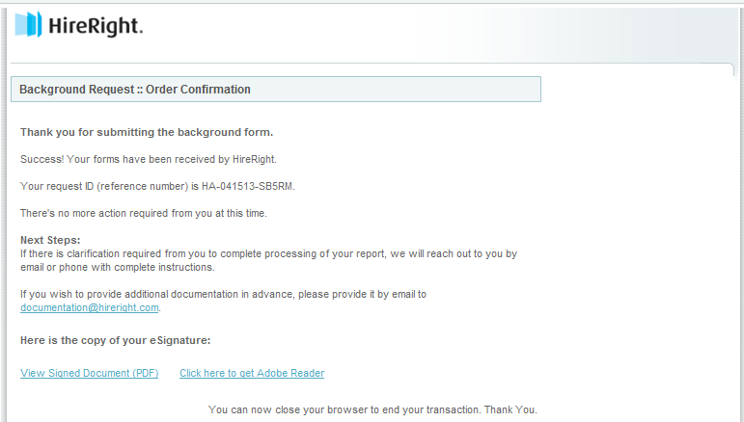

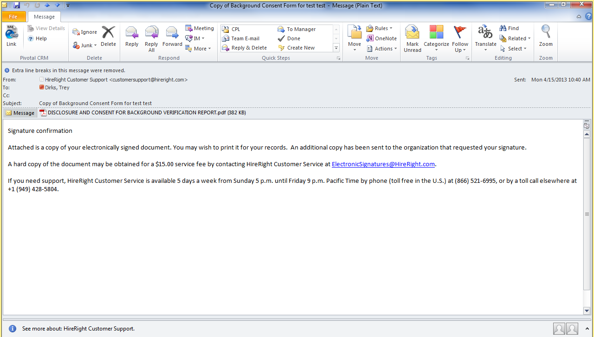

Frequently asked questions
What is a party in Interest?
Corporation, LLC or Partnership – Principals, Owners, Stockholders, Members, Partners, Directors and Officers.
Attorney Title Agent (3 or Less Attorneys) – All Attorneys, Principals and Owners.

Attorney Title Agent (4 or More Attorneys) – Attorneys Involved in Real Estate Practice, Principals and Owners.
Why is it necessary to complete and submit so many consumer report related documents?
The use of consumer reports is strictly regulated by federal and in some cases, state laws. The Fair Credit Reporting Act (FCRA) defines the federal regulations that we must adhere to when using the reports.
Can I get a copy of my employee’s consumer report for my own use?
No. First American performs these consumer reports exclusively for its own benefit. Specifically, First American’s use of these consumer reports is in no way to be relied on by a title agent, or anyone else, for any other purpose. Should you desire to review consumer reports for your own benefit, we encourage you to do so separately.
Why do you notify my employee before notifying me?
If we take an adverse action related to a consumer report, we are obligated under the FCRA to notify the subject of the report first and we do so by letter. Only after notifying the subject of the report can we notify the Principal of the Title Agency or your designated administrator regarding the matter.
If there needs to be communication with my employee, what will he/she receive?
If we need to take adverse action related to consumer reports, we will send a formal letter to your employee. In general, the letters state the individual may lose the ability to continue as an authorized signatory and/or lose the ability to handle closing disbursements involving a First American Title transaction. We also include a statement of the individual’s rights under FCRA.
How will I learn if there has been an issue with someone’s consumer reports?
After the subject of the report is notified, we will send you a letter. This letter may ask that the agency relationship continue so long as the individual is removed from the restricted activities at the Title Agency. It is also possible that First American may decide to terminate the agency relationship. Termination may occur if the subject of the review is an owner or if the Title Agency is unable or unwilling to meet the conditional request regarding an employee.

Will the consumer report affect my credit score?
No, it is referred to as a soft hit and will not affect your credit score.

First American values its Agency relationships and hopes this explanation will assist us in working together through this process.

