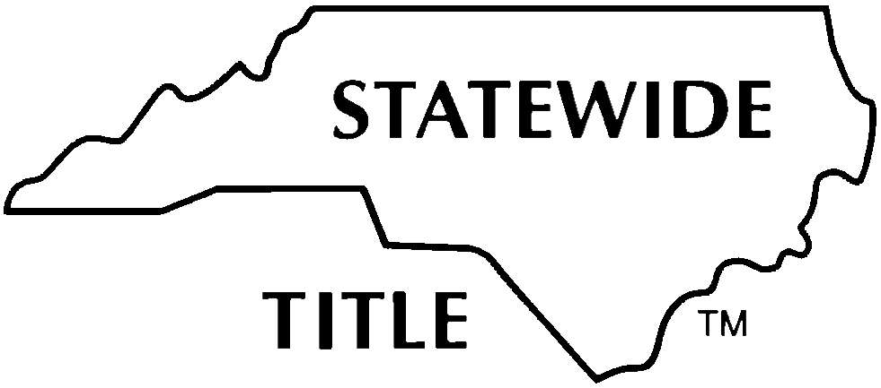
STATEWIDE TITLE, INC.
OWNER AFFIDAVIT AND INDEMNITY AGREEMENT
(MLA – CONSTRUCTION COMPLETED, CONTEMPLATED OR UNDER WAY)

OWNER:
(NOTE: A separate Agreement is required for each successive owner in the 120-Day Lien Period)

LAND:

(Insert street address or brief description and/or attach a description as Exhibit A.)

MLA Entry Number: ________________________

DEFINITIONS: The following capitalized terms as used in this Agreement shall have the following meanings:
- Improvement: All or any part of any building, structure, erection, alteration, demolition, excavation, clearing, grading, filling, or landscaping, including trees and shrubbery, driveways, and private roadways on the Land as defined below.
- Labor, Services or Materials: ALL labor, services, materials for which a lien can be claimed under NCGS Chapter 44A, Article 2, including but not limited to professional design services (including architectural, engineering, landscaping and surveying) and/or rental equipment.
- Owner: Any person or entity, as defined in NCGS Chapter 44A, Article 2, who has contracted for labor, services and/or materials for improvements on the Land and who has or has had any interest in the Land within the 120-Day Lien Period. For the purposes of this Agreement, the term Owner includes: (i) a seller of the Land or a borrower under a loan agreement secured by the Land; (ii) a person with rights to purchase the Land under a contract and for whom an Improvement is made and who ordered the Improvement to be made; and (iii) the Owner’s successors in interest and agents of the Owner acting within their authority.
- Company: The title insurance company providing the title policy for the transaction contemplated by the Owner herein as a seller or borrower.
- Lender - INSERT NAME(S): , and its/their successor and/or assigns.
- Deed of Trust: The real estate security instrument(s) to be executed by Owner and to encumber the Land in the currently contemplated transaction and any currently contemplated or future extensions, renewals, modifications, amendments or reinstatements thereof.
- Land: The real estate described above or on Exhibit A and any leaseholds, tenements, hereditaments, and improvements placed thereon, including any real estate that is a portion of a larger, previously unsegregated tract when that area is reasonably necessary for the convenient use and occupation of Improvements on the larger tract.
- MLA: Mechanic’s Lien Agent: A title insurance company or agency designated by an Owner pursuant to NCGS 44A-11.1.
- Potential Lien Claimant: any person or entity who has performed or furnished or has contracted to perform or furnish Labor, Services or Materials pursuant to a contract, either express or implied, for the making of an Improvement on the Land and is entitled to claim a lien for improvements to real Land under Article 2 of NCGS Chapter 44A.
- Design Professional: Any architect, engineer, land surveyor or landscape architect registered under NCGS Chapter 83A, 89A, or 89C.
- Custom Contractor: A contractor duly licensed as a general contractor pursuant to Article 1 of Chapter 87 of the General Statutes who has contracted with an owner who is not an affiliate, relative, or insider of the contractor to build a single-family residence on the Owner’s property to be occupied by the Owner as a residence.
- All defined terms shall include the singular or plural as required by context.

AGREEMENT: For good and valuable consideration, the receipt and sufficiency of which is hereby acknowledged, and as an inducement to the purchase of the Land by a purchaser and/or the making of a loan by Lender secured by the Deed of Trust encumbering the Land and the issuance of a title insurance policy or policies by Company insuring priority of title to the Land over claims of lien for Labor, Services or Materials; Owner(s), first being duly sworn, depose, say and agree:

- Owner’s Certifications:
- Owner certifies that an MLA has been designated for this Land and Owner has complied with all requirements of NCGS 44A 11.1 -11.2, including, but not limited to:
  - Provision of contact information for MLA to Potential Lien Claimant(s) requesting such information in accordance with NCGS 44A -11.2,
  - Appointment of MLA has been conspicuously and continuously posted on the Land in accordance with NCGS 44A -11.2,
  - Identification to the MLA of any Custom Contractor in contract with Owner for Improvements to Land consisting of a single family residence in accordance with NCGS 44A - 11.2,
  - Identification to the MLA of all Design Professionals and any party with whom Owner contracted prior to the appointment of the MLA that have been engaged in connection with the Improvements to the Land in accordance with NCGS 44A - 11.2;
Except as evidenced by the NCLTA Form 6 or Form 7 submitted herewith, (ii) there are no filed liens for Labor, Services or Materials for Improvements on the Land; (iii) Owner has not received any Notice of Claim of Lien upon Funds from any other person or entity; (iv) Owner has no knowledge of any other type of claim outstanding which would entitle the holder thereof to claim a lien on or interest in the Land including retention of title agreements or security interests for any materials, appliances, fixtures or furnishings placed upon or installed on the Land; (v) there are no Potential Lien Claimants who have contracted with the Owner whose first furnishing of Labor, Services or Materials is or may be within the 15 days immediately preceding the date of recordation of the latter of the deed to purchaser or Deed of Trust to Lender, as referenced herein, in the Office of the Register of Deeds of the county in which the Land is located (the 15 Day Period) except the following:
_____________________________________________________________________________________________________________________________

_____________________________________________________________________________________________________________________________

_____________________________________________________________________________________________________________________________

_____________________________________________________________________________________________________________________________

_____________________________________________________________________________________________________________________________
[Note: NCLTA Form 6 or 7 is also required from any Potential Lien Claimant and/or Design Professional who has filed a notice to MLA.]

- Reliance and Indemnification:
This Agreement may be relied upon by the purchaser in the purchase of the Land, Lender to make a loan secured by the Deed of Trust encumbering the Land and by Company in issuance of a title insurance policy or policies insuring title to the Land without exception to matters certified in this Agreement. The provisions of this Agreement shall survive the disbursement of funds and closing of this transaction and shall be binding upon Owner and anyone claiming by, through or under them.

Owner agrees to indemnify and hold purchaser, Lender, and Company harmless of and from any and all loss, cost, damage and expense of every kind, and attorney’s fees, costs and expenses, which the purchaser, Lender or Company shall or may incur or become liable for, directly or indirectly, as a result of reliance on the respective certifications of Owner made herein or in enforcement of the Company’s rights hereunder.

- NCLTA Copyright and Entire Agreement:
This Agreement and any attachments hereto represent the entire agreement between Owner and Company and no prior or contemporaneous agreement or understanding inconsistent herewith (whether oral or written) pertaining to such matters is effective.

THIS IS A COPYRIGHT FORM and any variances in the form provisions hereof must be specifically stated in the blank below and agreed to in writing by the Company.

No modification of this Agreement, and no waiver of any of its terms or conditions, shall be effective unless made in writing and approved by the Company.

PROVIDING A FALSE AFFIDAVIT IS A CRIMINAL OFFENSE
EXECUTION
(SEAL)  By:  Printed or Typed Name/Title:  By:  Printed or Typed Name/Title: | State of County of  Signed and sworn to (or affirmed) before me this day by  [insert name(s) of principal(s)].  Date:  , Notary Public  My Commission Expires: | (Affix Official/Notarial Seal)

EXHIBIT A
OWNER AFFIDAVIT AND INDEMNITY AGREEMENT
(MLA – CONSTRUCTION COMPLETED, CONTEMPLATED OR UNDER WAY)

