STATEWIDE TITLE, INC.
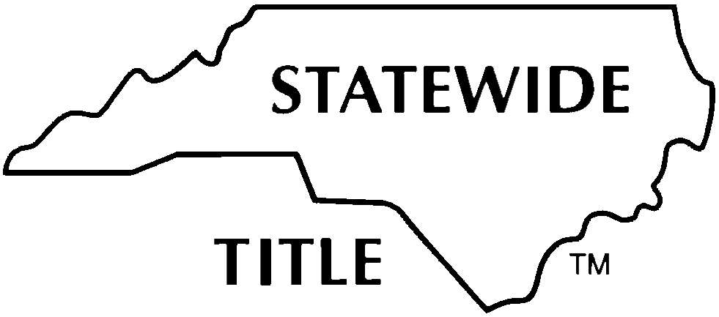
WAIVER AND RELEASE OF LIENS
(MLA APPOINTED)

POTENTIAL LIEN CLAIMANT, _______________________________________________________________________, (hereinafter, “Potential Lien Claimant”)

PROPERTY (Required): __________________________________________________________________________________________________________
_______________________________________________________________________________________________________________________________
(Insert street address or brief description and/or attach a description as Exhibit A.)

DEFINITIONS: The following capitalized terms as used in this Waiver and Release of Liens (“Waiver”) shall have the following meanings:
- Company: any title insurance company issuing a title policy or policies insuring title to the Property in reliance on this Waiver.
- Lender: a lender making a loan secured by a deed of trust encumbering the Property.

- Certifications and Waiver:
For good and valuable consideration, the receipt and sufficiency of which is hereby acknowledged, and other benefits accruing, Potential Lien Claimant certifies that (i) he/she/it has signed this Waiver in the correct legal capacity and has the authority to sign this Waiver; (ii) such Potential Lien Claimant has not received any Notice of Claim of Lien upon Funds or Claim of Lien on Real Property from any other person or entity.

Potential Lien Claimant waives and releases any lien, claim of lien or other interest whatsoever which such Potential Lien Claimant or anyone claiming by, through, or under such Potential Lien Claimant might have in the Property. Potential Lien Claimant waives and releases any right or protection Potential Lien Claimant may have arising out of any Notice to Lien Agent that Potential Lien Claimant has filed relating to the Property in accordance with the provisions of NCGS 44A-11.2 for work performed prior to and after execution of this Waiver.
- Reliance:
This Agreement may be relied upon by the purchaser in the purchase of the Property, Lender to make a loan secured by the Deed of Trust encumbering the Property and by Company in issuance of a title insurance policy or policies insuring title to the Property without exception to matters certified in this Agreement. The provisions of this Agreement shall survive the disbursement of funds and closing of this transaction and shall be binding upon Potential Lien Claimant (and anyone claiming by, through or under them).

- NCLTA Copyright :
THIS IS A COPYRIGHT FORM and any variances in the form provisions hereof must be specifically stated in the blank below and agreed to in writing by the Company.

No modification of this Waiver, and no waiver of any of its terms or conditions, shall be effective unless made in writing and approved by the Company.

POTENTIAL LIEN CLAIMANT:

(SEAL)

By:
Printed or Typed Name/Title:

By:
Printed or Typed Name/Title:

DATE: ___________________________________________

