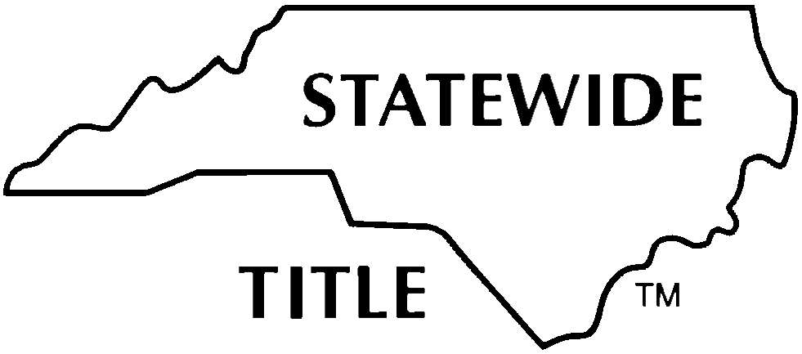

CORRECTIVE OR SCRIVENER’S AFFIDAVIT FOR

NOTICE OF TYPOGRAPHICAL OR OTHER MINOR ERROR
[N.C.G.S. 47-36.1]

Prepared by:

Each undersigned Affiant, jointly and severally, being first duly sworn, hereby swears or affirms that the ____________________________________________________________ (name or type of instrument) recorded on _________________________ (date) in Book _____, Page _____, ________________________ County Registry, by and between
______________________________________________ (original parties) contained typographical or minor error(s); and this Affidavit is made to give notice of the following corrective information:

Affiant is knowledgeable of the agreement and the intention of the parties in this regard. Affiant is the (check one)

Drafter or preparer of the previously recorded instrument
Closing attorney for transaction involving the previously recorded instrument
Attorney for grantor/mortgagor named above in the previously recorded instrument
Owner of the property described in the previously recorded instrument
Other (Explain: )

A copy of the previously recorded instrument (in part or in whole) (___) is / (___) is not attached.

Signature of Affiant Signature of Affiant
Print or Type Name: Print or Type Name:

State of County of  Signed and sworn to (or affirmed) before me, this the _____ day  of ________________________, 20___.  My Commission Expires:  Notary Public | (Affix Official/Notarial Seal)

